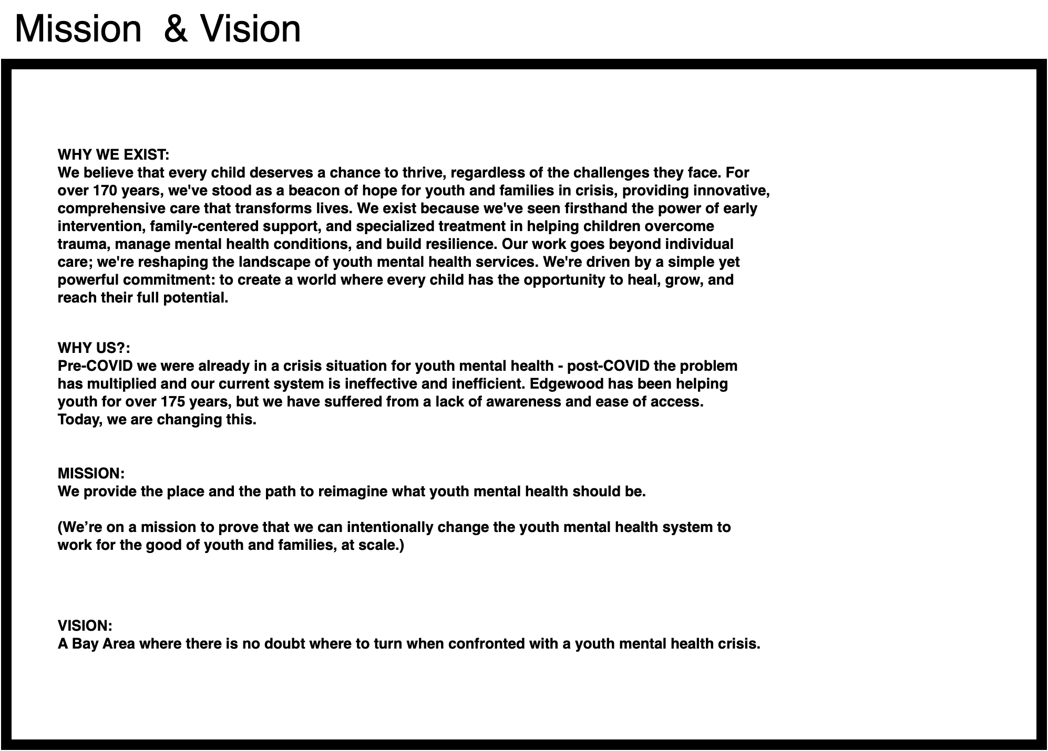
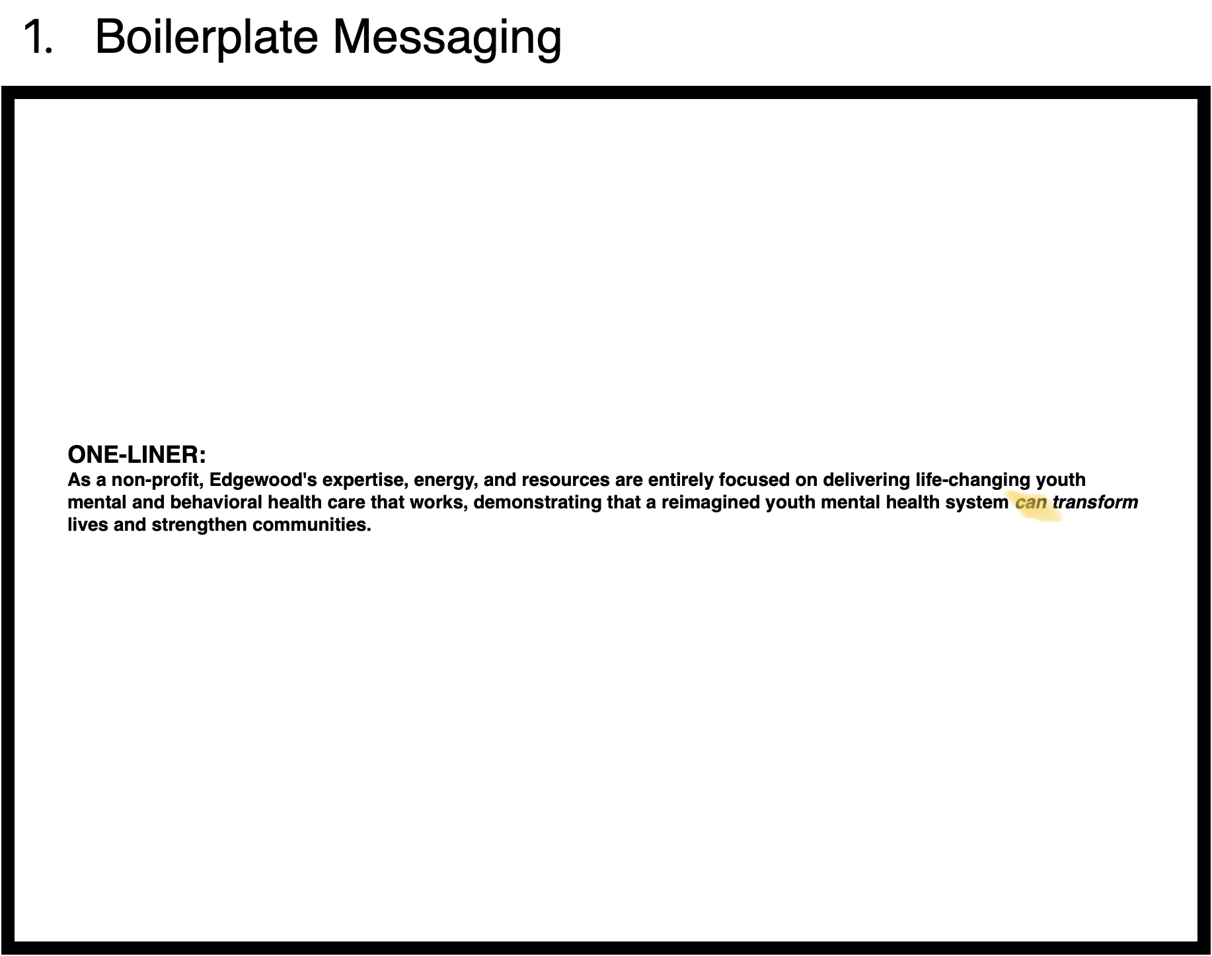
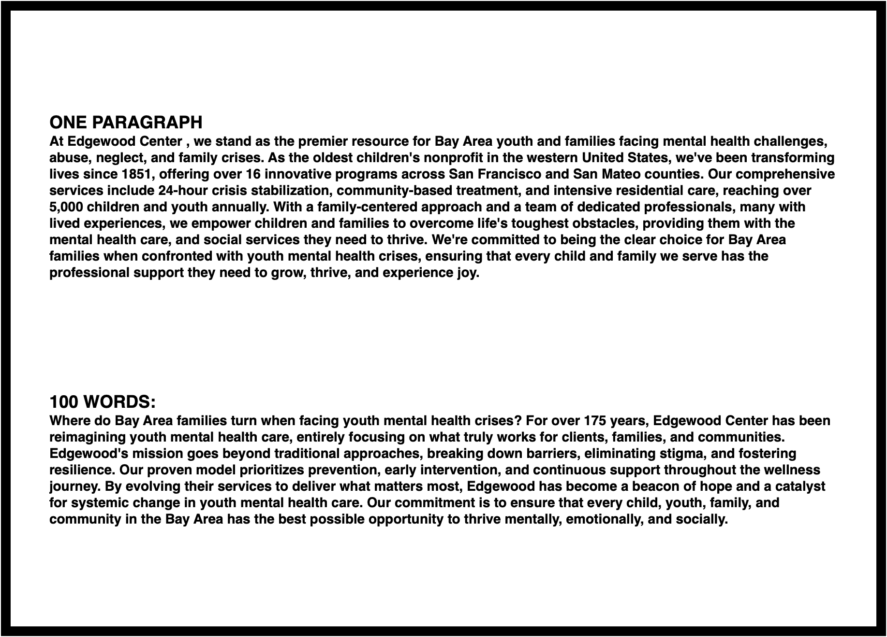
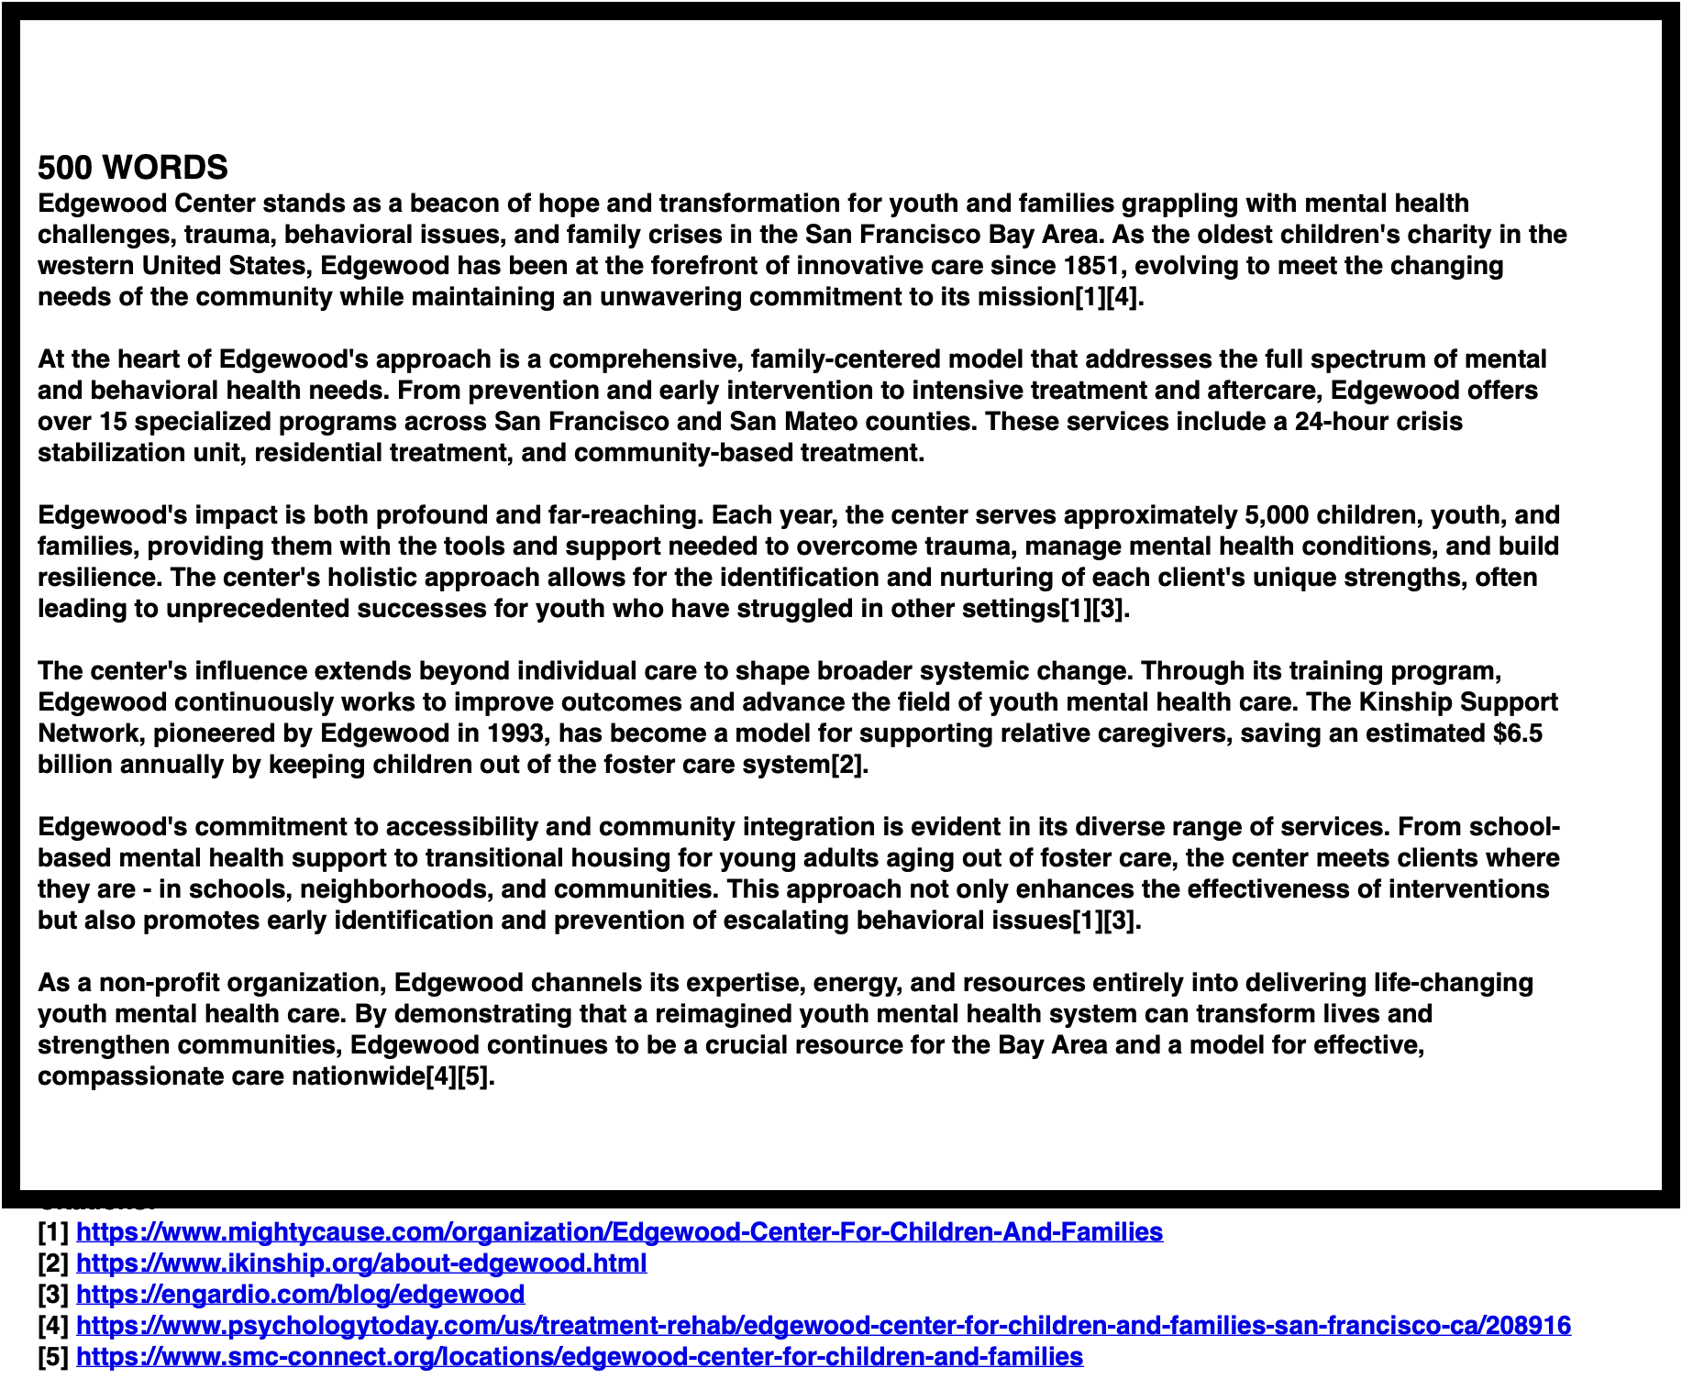
.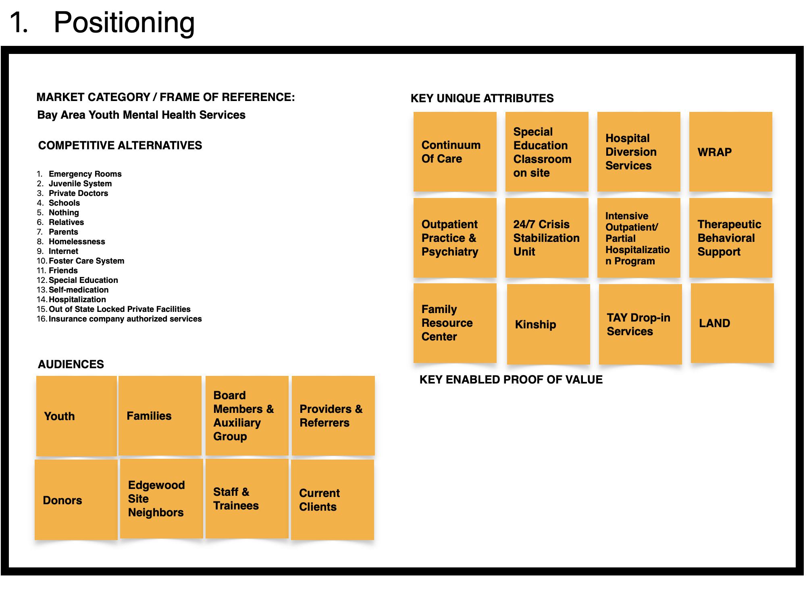
We are the heart of youth mental health in the Bay Area—a place where every young person and family feels seen, supported, and inspired. We strive to be a beacon in mental health care, setting the standard for innovative, compassionate, and lasting impact in our community, creating pathways to brighter futures for every child we serve.

